Progress Report: Predictive Modeling of S&P 500 Stock Returns using Machine Learning

1. Overview of Progress

To date, the initial phase of the analysis, involving the implementation and evaluation of baseline machine learning models—specifically LASSO regression and Random Forest—has been completed. This report details the methodology I adopted for these models, summarizes their out-of-sample performance, and sets the stage for the subsequent Bayesian analysis.

2. Data and Preprocessing (Brief Recap)

The analysis utilizes two primary data sources:
* S&P 500 Constituent Data: Monthly historical S&P 500 constituent lists, `permno` (primary stock identifier), and monthly stock returns (`ret`) were sourced from the CRSP database, covering the period from January 1965 to December 2023.
* Stock-Level Characteristics: A comprehensive dataset of 153 monthly stock-level characteristics for all US stocks from 1965 to 2023 was obtained from the WRDS database.

Key preprocessing steps undertaken to create the final analytical dataset (`sp500_factors_final_for_modeling.parquet`) include:
1. Merging: The S&P 500 constituent data was merged with the stock-level characteristics based on `permno` and `date`.
2. Date Alignment:All `date` columns were standardized to represent month-end dates to ensure consistency for merging and time-series analysis.
3. Missing Value Imputation for Characteristics: Missing values in the 153 factor columns were imputed using the cross-sectional median for each factor in each month. This approach was chosen to maintain the integrity of the feature set for subsequent model-based variable selection, as per the methodology in Gu, Kelly, and Xiu (2020).
4. Factor Standardization: All 153 stock characteristics were cross-sectionally rank-standardized period-by-period and mapped into the [-1,1] interval, following Gu, Kelly, and Xiu (2020). This non-linear transformation handles outliers and skewed distributions robustly.
5. Target Variable Creation: The dependent variable, `target_ret_t_plus_1`, was created by shifting the monthly returns (`ret`) by one period forward for each stock. This ensures that models predict next month's return using information available up to the end of the current month. Rows with NaN values for the target variable (primarily the last observation for each stock) were dropped.

3. Modeling Methodology: Dynamic Out-of-Sample Evaluation

I adopted a rigorous dynamic out-of-sample evaluation framework, inspired by Gu, Kelly, and Xiu (2020, "Empirical Asset Pricing via Machine Learning"), to assess model performance realistically and minimize look-ahead bias.

3.1. Three-Way Data Split:
I divided the data as follows:
* Initial Training Period (1965–1989): This 25-year period was used for initial model fitting, preliminary hyperparameter exploration, and establishing baseline parameter estimates.
* Validation Period (1990–2004):This 15-year period served a critical role in selecting and validating the *hyperparameter tuning strategy* for each model type (LASSO and Random Forest). The objective was not to pick a single set of fixed hyperparameters for the entire OOS period, but rather to determine the most effective *method* for tuning these hyperparameters dynamically. Basically I compared model performances on the validation period where I optimized hyper parameters on a rolling window, and where a used a fixed value for hyper parameters decided on the training period. If the adaptive strategy performed better, I used that for the OOS test.
* Out-of-Sample (OOS) Test Period (2005–2023): This 19-year period was strictly reserved for evaluating the true out-of-sample predictive performance of the finalized models and their respective dynamic updating and hyperparameter tuning strategies. Data from this period was not used in any prior model development or strategy selection phase.

3.2. Dynamic Modeling with Expanding Window:
For both LASSO and Random Forest models during the validation and OOS test periods:
* Model parameters were re-estimated annually before making predictions for the subsequent 12 months.
* The training sample used for these annual re-estimations employed an expanding window: all available historical data from the start of the sample (1965) up to the end of the year immediately preceding the prediction year was used. This window expanded by one year for each subsequent year of predictions.

3.3. Hyperparameter Tuning Strategy:

* LASSO Regression:
* The LASSO penalty term, λ (alpha), was adaptively re-tuned annually.
* This re-tuning was performed using 5-fold time-series cross-validation conducted within the current expanding training sample for that specific period.
* Analysis during the validation period (1990-2004) confirmed that this adaptive λ strategy yielded slightly superior portfolio sort performance and comparable (or marginally better) statistical metrics compared to using a fixed λ derived from the initial training period. The optimal λ was observed to vary over time, supporting the adaptive approach.

* Random Forest (RF):
* Key hyperparameters considered for tuning included tree depth (`max_depth`), number of features per split (`max_features`), minimum samples per split (`min_samples_split`), and minimum samples per leaf (`min_samples_leaf`). The number of trees (`n_estimators`) was set to 300, following literature (e.g., GKX 2020).
* During the validation period (1990-2004), a strategy of adaptively re-tuning these hyperparameters annually (via `GridSearchCV` on the expanding window) was compared against using a fixed set of hyperparameters. The fixed set was derived from a comprehensive `GridSearchCV` on the initial 1965-1989 training data (`{'max_depth': 6, 'max_features': 50, 'min_samples_leaf': 50, 'min_samples_split': 50}`).
* The validation period results indicated that the Random Forest with these fixed hyperparameters (while still being retrained annually on the expanding data window) yielded slightly better and more stable long-short portfolio performance (higher mean return and Sharpe ratio) than the adaptive hyperparameter strategy for RF. Consequently, the fixed hyperparameter approach was chosen for the OOS evaluation of the Random Forest model.

4. Evaluation of Predictive Performance

While statistical metrics like Mean Squared Error (MSE) and Out-of-Sample R² were calculated, predicting financial returns down to the decimal is very difficult, often resulting in low values. Therefore, to assess the economic significance and practical utility of the models, the primary evaluation focused on portfolio sorts, a standard methodology in empirical asset pricing literature (e.g., Gu, Kelly, and Xiu, 2020).

This involves:
1. Ranking stocks each month based on model-predicted returns.
2. Forming equal-weighted decile portfolios.
3. Constructing a long-short strategy (top decile - bottom decile).
4. Evaluating this strategy using:
* Mean Monthly Return.
* Annualized Sharpe Ratio (assuming a zero risk-free rate for simplicity).
* Cumulative Return Plots.
Additionally, the Mean Monthly Rank Information Coefficient (IC) and its stability (IC Sharpe Ratio) were computed to assess the ordinal predictive accuracy of the models.

5. Summary of Baseline Model Results (LASSO and Random Forest OOS: 2005-2023)
Adaptive CV Strategy OOS (2005-2023):
Overall MSE: 0.008675
Overall OOS R2: -0.0030

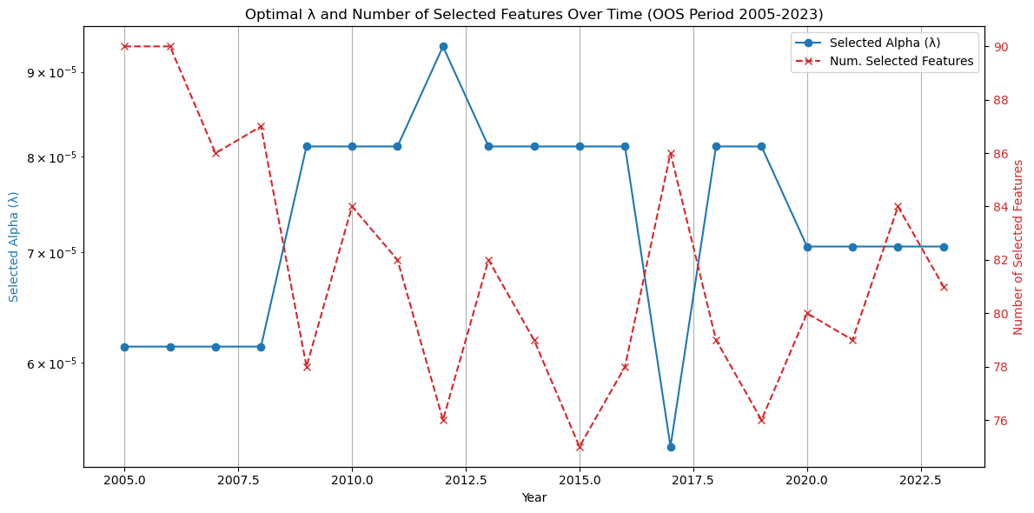

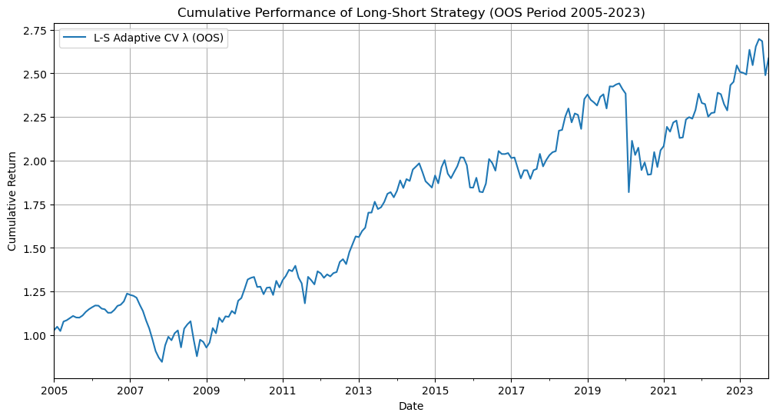
Mean Monthly L-S Return: 0.5045%
Annualized L-S Sharpe Ratio: 0.43
Fixed RF Params Strategy OOS (2005-2023):
Overall MSE: 0.008655
Overall OOS R2 (vs initial train mean benchmark): -0.0007
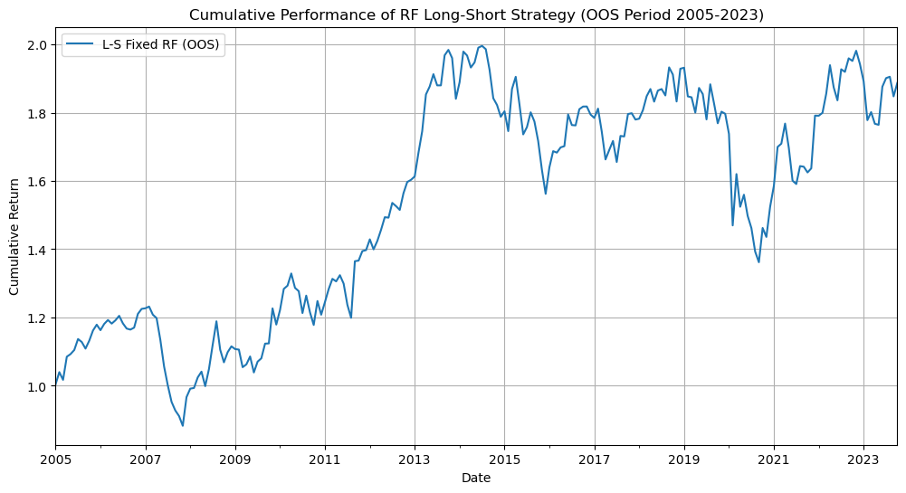

Fixed RF Params (OOS 2005-2023)
Long-Short Portfolio (Top 10.0% - Bottom 10.0%):
Mean Monthly Return: 0.3452%
Annualized Sharpe Ratio: 0.33
Key Out-of-Sample Findings (2005-2023):
* Both LASSO (with adaptive λ) and Random Forest (with fixed optimal hyperparameters) demonstrated an ability to generate positive mean monthly returns from long-short decile portfolios, suggesting some predictive power.
* The LASSO model generally exhibited more favorable out-of-sample performance. It achieved a higher long-short portfolio mean monthly return (0.5045%) and annualized Sharpe ratio (0.43) compared to the Random Forest (0.3452% and 0.33, respectively).
* The Mean Rank IC for LASSO (0.0178) was also higher than that for the Random Forest (0.0091), indicating a slightly more consistent ordinal ranking ability for LASSO.
* Both models yielded slightly negative overall OOS R² values (LASSO: -0.0030, RF: -0.0007) when benchmarked against the 1965-1989 training mean return, highlighting the difficulty in achieving high point-prediction accuracy for noisy stock returns.
* A notable degradation in portfolio performance was observed for both models when moving from the 1990-2004 validation period to the 2005-2023 OOS test period. This is a common finding, reflecting the challenges of out-of-sample generalization in dynamic market environments, which included significant events like the 2008 Global Financial Crisis and the COVID-19 pandemic.
* The relatively simpler, linear LASSO model provided more robust out-of-sample results in terms of economic significance (portfolio sorts) than the more complex Random Forest. This suggests that for this dataset and prediction task, the non-linearities captured by Random Forest did not translate into superior OOS performance, and the model might have been more sensitive to overfitting or changing data regimes despite the retraining.

6. Bayesian MCMC Framework: Staged Development and Current Progress

The performance of the LASSO and Random Forest models provides valuable benchmarks and highlights the potential for further refinement in variable selection and uncertainty quantification. The LASSO, in particular, showed some promise in identifying predictive signals. To build upon this, and to address the core research question regarding the efficacy of a more formal probabilistic approach, I am implementing the Bayesian hierarchical modeling framework.

The implementation of this Bayesian model is following a structured, staged approach to manage complexity, ensure model stability, and facilitate diagnostics:

* Stage 1: Simplified Bayesian Spike-and-Slab with Global Parameters (Currently Underway)
* Objective: To establish a foundational Bayesian variable selection model and validate the core MCMC (PyMC) setup, sampling procedures, and convergence diagnostics on the initial training dataset (1965-1989).
* Model: This initial model simplifies the full specification by assuming a global intercept (alpha), a global error variance for all stock-month observations, and global spike and slab variances for the factor coefficients (beta). Individual factor inclusion probabilities (pi) are drawn from a common (Beta(1,1) prior.
* Current Status: This model is currently being fitted to the 1965-1989 training data. The primary outputs will be posterior distributions for (betas), Posterior Inclusion Probabilities (PIPs) for each of the 153 factors, and MCMC convergence metrics.

* Stage 2: Incorporating Stock-Specific Effects (Planned)
* Objective: To enhance model realism by allowing for heterogeneity across individual stocks, specifically in their baseline predictability (intercepts) and residual volatility.
* Planned Model Enhancements: This stage will build upon the Stage 1 model by introducing:
* Stock-specific intercepts (hierarchical).
* Stock-specific error variances (potentially hierarchical).
* Utility: This stage will help assess the impact of accounting for firm-level heterogeneity on factor selection and overall model fit, before introducing further thematic structure.

* Stage 3: Introducing Theme-Informed Hierarchical Spike-and-Slab (Planned Target Model)
* Objective: To implement the full hierarchical model where the "slab" component of the spike-and-slab prior for factor coefficients (beta) is informed by economic themes, and theme-level inclusion probabilities (pi) can be influenced by external research (e.g., JKP (2023) factor replicability).
* Planned Model Enhancements: This stage will modify the slab component for beta to N(mu_k, tau_k^2) where mu_k and tau_k^2 are theme-specific parameters with their own priors. The prior for pi_k (theme-level inclusion probability) will be structured to incorporate JKP findings.
* Utility: This is the target specification designed to test the central hypothesis about my Bayesian framework's ability to discern significant predictors within an economically meaningful structure. It allows for borrowing strength across factors within the same theme.

* Stage 4: Dynamic Out-of-Sample Evaluation (Planned)
* Objective: To rigorously evaluate the out-of-sample predictive performance of the chosen Bayesian model specification (from Stages 1-3, likely the most complex stable version) using the established dynamic expanding window methodology across the validation (1990-2004) and final OOS test (2005-2023) periods.
* Utility: This will provide a direct comparison of the Bayesian model's predictive accuracy (MSE, OOS R²), economic significance (portfolio sorts), and factor selection stability (PIPs over time) against the LASSO and Random Forest benchmarks.

This staged implementation allows for systematic debugging, refinement of priors, and assessment of computational feasibility at each step before proceeding to the full dynamic evaluation. The current focus is on successfully completing and diagnosing Stage 1.

